Layer 3 Switch Virtual Interfaces

We will use the network topology shown below:

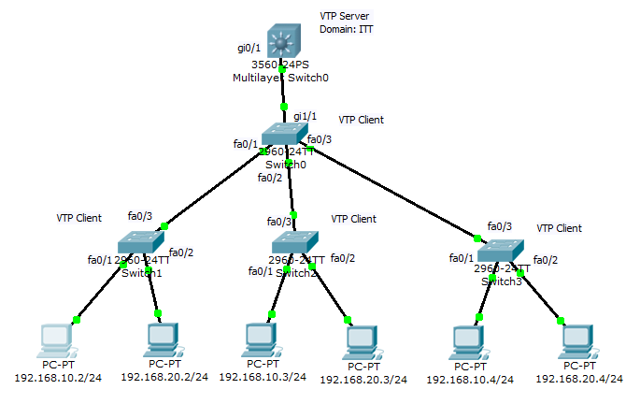

We replace the router with a Layer 3 Switch to create Switch Virtual Interfaces to route between the VLANs. The configuration on the layer 2 switches will be as normal.

1. Configure the PCs as shown – make sure to set default gateways – 192.168.10.1, etc.
2. Set Multilayer Switch0 as the VTP server, set others as VTP clients. Set VTP domain name ITT on the server. Let the clients learn the domain name.
3. Enable trunking on ports connecting switches and set native VLAN to 99.
4. Check that the clients have learned the domain name – **show vtp status**
5. Create VLANs 10, 20, and 99 on VTP server.
6. Check that other switches have learned VLANS – **show vlan**.
7. Assign PCs to VLANs 10 and 20 as shown above.
8. Set IP addresses on switches as shown in table below:

|  |  |
| --- | --- |
| Switch0 | 192.168.99.10/24 |
| Switch1 | 192.168.99.11/24 |
| Switch2 | 192.168.99.12/24 |
| Switch3 | 192.168.99.13/24 |

1. Set default gateway on all switches to 192.168.99.1
2. On Layer 3 switch:
   1. Enable IP routing: **conf t**

**ip routing**

* 1. Set native VLAN on gi0/1 to 99
  2. Create SVIs for VLANs 1, 10, 20, 99 as follows:

**Switch(config)#int vlan 1**

**Switch(config-if)#ip add 192.168.1.1 255.255.255.0**

Repeat the process for VLANs 10, 20, and 99.

When you look in the routing table on the switch you should see something like this:

**Switch#sh ip route**

Codes: C - connected, S - static, I - IGRP, R - RIP, M - mobile, B - BGP

D - EIGRP, EX - EIGRP external, O - OSPF, IA - OSPF inter area

N1 - OSPF NSSA external type 1, N2 - OSPF NSSA external type 2

E1 - OSPF external type 1, E2 - OSPF external type 2, E - EGP

i - IS-IS, L1 - IS-IS level-1, L2 - IS-IS level-2, ia - IS-IS inter area

* - candidate default, U - per-user static route, o - ODR

P - periodic downloaded static route

Gateway of last resort is not set

192.168.0.0/24 is subnetted, 4 subnets

C 192.168.1.0 is directly connected, Vlan1

C 192.168.10.0 is directly connected, Vlan10

C 192.168.20.0 is directly connected, Vlan20

C 192.168.99.0 is directly connected, Vlan99

**Try pinging between VLANs.**

**The layer 3 switch is now aware of the different VLANs and subnet addresses and can route between VLANs while using a single physical interface.**